Restorative, Relational Justice:
A Whole-school Approach

Restorative justice is an approach to achieving justice that involves, to the extent possible, those who have a stake in a specific offense or harm to collectively identify and address harms, needs, and obligations in order to heal and put things as right as possible.
- Zehr, 2015, p. 48

Restorative justice is an approach to both the prevention of and response to harm to people and relationships. Often contrasted with punitive measures, restorative justice originated as a response to criminal harm and has expanded to workplace, school, and every day applications. Restorative justice approaches are grounded in values of respect, inclusion, accountability, safety, voluntariness, trust, honesty, and humility. Restorative processes include face-to-face dialogues, restorative enquiries, and circle processes. When integrated into institutions, restorative justice can promote social justice, safety, and inclusion. Also referred to as transformative justice, restorative approaches seek to address not only the interpersonal aspects of harm but also the social and structural inequalities that create and perpetuate harm.

Transformative, restorative justice focuses on a given point in time and on the specific people who are involved with one another at that time, as well as directing attention to both the preconditions and antecedents of that particular moment, which generally implicate factors and forces that go beyond the individuals most directly affected.
- Harris, 2004, p. 139
Restorative, relational justice is a philosophy based on the following values.
Participation: Those most affected by the incident of wrongdoing or harm ought to be the principal speakers and decisionmakers in the process, rather than trained professionals representing the interests of the institution or state.
Respect: All human beings have inherent and equal worth irrespective of their actions, good or bad, or of their race, culture, gender, sexual orientation, age, beliefs or status in society. All therefore deserve to be spoken to and treated with respect.
Honesty: Truthful speech is essential if justice is to be done. In restorative justice, truth entails more than clarifying the facts and establishing guilt; it requires people to speak openly and honestly about their experience, their feelings and their moral responsibilities.
Humility: All human beings are fallible. Empathy and mutual care are manifestations of humility.
Interconnectedness: While stressing individual freedom and accountability, restorative justice recognises the communal bonds that unite people. All people are viewed as valued members of society, a society in which all people are interconnected by a web of relationships. Society shares responsibility for its members and for the existence of harm, and there is a shared responsibility to help restore people and relationships.
Accountability: When a person inflicts harm on another, the perpetrator or offending institution has a moral obligation to accept responsibility for having done so and for mitigating the consequences that have ensued. Restorative justice invites people who have caused harm to take responsibility for their actions, to do what they can to remedy the harm they have inflicted, and to begin a rehabilitative and re-integrative process.
Empowerment: All human beings require a degree of self-determination and autonomy in their lives. Restorative justice seeks to empower all people impacted by harm by giving them an active role in determining what their needs are and how these should be met.
Hope: No matter how severe the wrongdoing, it is always possible for the community to respond in ways that lend strength to those who are suffering and that promote healing and change.
- Adapted from the Restorative Justice Network, Christchurch, NZ
Restorative justice practices, approaches and actions are guided by the following questions and principles.
Retributive/punitive Questions | Restorative, Relational Questions
- What rule has been broken?  - Who did it?  - What do they deserve? | - Who has been harmed?  - Who and what relationships have been impacted? How have they been affected?  - What needs exist?  - Whose obligation is it to address these?  - What needs to happen to address the harm and begin to promote healing of people and relationships?

Principles of Working Restoratively
- Relationship-centred: focused on understanding and promoting just interconnections between individuals, groups and communities
- Comprehensive and holistic: taking into account the contexts and causes of harm and its impacts
- Inclusive and participatory: culturally appropriate, and trauma-informed; attentive to the safety and well-being of participants
- Responsive: contextual, flexible in practice
- Focused on individual and collective responsibility
- Collaborative and non-adversarial
- Forward-focused: educative, not punitive; problem-solving, preventative and proactive
  - Lewellyn, 2018
10 Ways to Live Restoratively
1. Take relationships seriously, envisioning yourself in an interconnected web of people, institutions, and the environment.
2. Try to be aware of the impact – potential as well as actual – of your actions on others and the environment.
3. When your actions negatively impact others, take responsibility by acknowledging and seeking to repair the harm – even when you could probably get away with avoiding or denying it.
4. Treat everyone respectfully, even those you don’t expect to encounter again, even those you feel don’t deserve it, even those who have harmed or offended you or others.
5. Involve those affected by a decision, as much as possible, in the decision-making process.
6. View the conflicts and harms in your life as opportunities.
7. Listen, deeply and compassionately, to others, seeing to understand even if you don’t agree with them. (Think about who you want to be in the later situation rather than just being right).
8. Engage in dialogue with others, even when what is being said is difficult, remaining open to learning from them and the encounter.
9. Be cautious about imposing your “truths” and views on other people and situations.
10. Sensitively confront everyday injustices including sexism, racism, homophobia, and classism.
  - Zehr, 2015
Restorative, relational justice: A whole school approach
Restorative justice (RJ) has been called many things when integrated into educational institutions: Restorative Principles, Restorative Practices, Restorative Discipline, Restorative Approaches, Restorative Measures, Restorative Justice Practices.
Within any school there is a continuum of interventions that aim to keep schools safe. Some are reactive and some are proactive. It is important to develop a synergy between proactive and reactive strategies that will unite approaches across a continuum of practice. Restorative justice must touch the culture of a school as a whole. The whole school model of restorative justice brings RJ values, principles and practices to three levels of intervention: Primary, secondary and tertiary. This is consistent with a number of other approaches including violence prevention and health care (Morrison, 2007, p. 106).

Tertiary: Intensive – Intervene

Secondary: Targeted – Maintain

Primary: Universal – Prevent & Educate

  - Morrison, 2007
Primary: Universal – Prevent & Educate
The primary (universal) level involves all members of the school community and is an “immunization” or “defense’ strategy so that conflict does not escalate when differences first arise. The aim is to develop and affirm each member of the school communities social and emotional competencies (Morrison, 2007, p. 107).
The primary (universal) level also involves building relationships and addressing protective factors to create connection, resilience and health. Initiatives at this level seek to identify and transform the social conditions and institutional policies that allow harm to take place and even normalized.
Some examples of universal initiatives are:

- Accessible workshops for all that build social and emotional skills
- Peer to peer support networks
- Written communication and policies containing restorative language and options
- Campus wide training of restorative justice to normalize restorative mindset, language and enquiry
- Onboarded faculty are provided access to workshops on conflict resolution skills, dealing with difficult people, stress management, emotional intelligence
- Student supports to enhance attendance and presence at school
    - Emotional and mental health supports
    - Financial support
    - Child and/or elder care
    - Physical safety (Safewalk, security, etc.)
- Student supports for academic performance
    - Language supports
    - Tutoring
    - Academic integrity
- Faculty supports
      - curriculum development
      - teaching and learning
      - restorative approaches to classroom management
      - authentic assessments

Secondary: Targeted – Maintaining relationships and restorative culture
The secondary or targeted level often involves small or medium sized group of the school community that has been impacted or is at risk of harm. In considering what makes someone or a group “at risk,” intersectionality considerations are central. A person-centered, needs based, restorative approach means that relationships are held as a central during problem solving. Some examples of secondary interventions are:
- Faculty meetings and supports to identify and address at risk students (Early alert, etc.)
- Reintegration circle following faculty, staff or student absence
- Classroom management
- Circle to discuss how to enhance equity, diversity, and inclusion on campus

Tertiary: Intensive – Intervening to Rebuild relationships and Repair Harm
The tertiary level involves the participation of all those who have been affected when a serious incident occurs. This could include a wider cross-section of the school community and even those outside the university (parents, police, etc.).
There are several well-established restorative processes that can be used to deal with more serious harms. One size does not fit all and care must be taken that these practices are facilitated by competent trained people. For a restorative process to move forward, there are several criteria that must be met. For most instances, the person who caused the harm must accept some level of responsibility for their actions and be open to making reparation. The needs of the persons harmed are held central. They must participate voluntarily and be provided opportunities to provide voice and choice in how the process will unfold. Community members might also be included and also must be informed and prepared to ensure the process itself upholds the values of respect, honesty, accountability, and safety. All parties must be fully prepared to move forward with a restorative process which could be face-to-face dialogue or involve indirect communication. Three models are described below and can be adapted to the situation and the needs of the participants.

Victim-Offender Dialogue
Victim-offender dialogue processes have been associated with restorative justice since the early 1970s. The approach involves facilitating communication between the victim/survivor and the person who caused them harm. The dialogue could be direct/face to face or indirect through exchanging letters or video recorded messages. A trained facilitator acts to explain the process, prepare each party, and facilitate the exchange. The encounter prioritizes physical and emotional safety, meaningful dialogue, and reparation of harm. People are not expected to leave the dialogue friends, rather the aims are to have gained understanding of what happened, the harm caused, and what is required for reparation to begin.

Conferencing
Conferencing evolved from practices from many parts of the world including New Zealand and Australia. Often a process used with youth, conferences are similar to victim-offender dialogue but involve more participants. These additional people might be family members of the victim and offender and other resource people that can support the restorative justice process. After preparation, participants come together to talk about what happened, who was impacted and how, and work together to form an agreement about how the harm can be repaired. Conferencing participants provide support to both victims and offenders, often providing accountability for the offender to complete the reparations they have agreed to.

Circles (sometimes called healing circles, peacemaking circles)
Circles have deep roots in many Indigenous traditions and worldviews. An ancient practice, circles have been brought into restorative justice in many ways. These processes bring victim, offenders, and community members together to talk about the harm caused, the impact, and come up with a way to repair the harm. Members of the circle provide both support and accountability to the main parties. Circles can be designed to include spiritual elements which may include opening prayers, passing a talking piece, and other cultural expressions that are meaningful to the group. Circles are used by both Indigenous and non-Indigenous peoples and can be adapted to meet the needs of people and communities.
Questions to Inventory Existing Restorative, Relational Approaches in your Department
Here are some questions that can be used to determine the restorative, relational principles and practices that already exist in your department. This inventory also promotes consideration of where restorative approaches might be added to or replace existing, punitive or non-relational practices.

Tertiary: Respond / Intervene
In what restorative, relational ways does your department respond when harm has been caused?
How often are restorative, dialogic processes used to promote the reparation of harm, building understanding, and reducing the risk of future harm by addressing root causes?
How the policy AD2 is used – complaint against faculty is first dealt with informally, dialogical right from the beginning – talking about harm and impact, no longer a blunt instrument /procedures, right of first response – primary opportunity for resolution, encourage direct dialogue, conflict coaching with students
Academic Integrity – Vision statement in process, intent is the full spectrum of RJ options, compassion based, person centered, educative
In future - KSA offering student support
Secondary: Maintain
When problems occur, how do you respond in a way that seeks to maintain a relational, respectful, inclusive culture?
Faculty/faculty conflict – team based charters, values exercises, acknowledge harm to community as a whole when two people are in conflict, clarify expectations and values in collaboration with HR, create a culture of support between faculty, self clarification of values and sharing those
What does your department do to support teachable moments?
Workshops on sexualized violence to promote conversation and learning

Primary: Prevent & Educate
What does your department do to prevent harm from occurring?
Institutional Onboarding process is fulsome (conflict of interest, Indigenous) in terms of education/orientation includes encouragement of upfront, clear class discussions of AI, preventative design/authentic assessment
AI Prevention – Academic integrity information, tutorial library, core writing intensive courses/intro courses
Student orientation on AI, normalizing stress and desperation and alternatives buying a paper
Future – departmental level welcome and on-boarding, these are our values – restating commitment to core values
What does your department do to build social and emotional skills? Workshops – not as whole departments, individuals or staff
Community building activities as staff
Welcoming, onboarding for staff, retreats where we affirm values
What does your department do to build healthy relationships?
What restorative, relational language exists in communication and policies?
What does your department do to support restorative justice language, principles, or enquiry?
How often are restorative processes like circles used to bring people together to promote relationship and community building?
Informal culture – conversation that involves all parties, identifies harm and how that can repaired and healing of people and relationships
Not shying away from difficult conversation (i.e. when someone leaves their position)
Is a knowledge of restorative justice favoured when hiring or providing opportunities for professional learning?

RJ Inventory Tool
What does your department do to support teachable moments?
Answer Here
Maintain
When problems occur, how do you respond in a way that seeks to maintain a relational, respectful, inclusive culture?
Answer Here
In what restorative, relational ways does your department respond when harm has been caused?
Answer Here
Respond / Intervene
How often are restorative, dialogic processes used to promote the reparation of harm, build understanding, and reduce the risk of future harm by addressing root causes?
Answer Here

What does your department do to build healthy relationships?
Answer Here
What restorative, relational language exists in communication and policies?
Answer Here
What does your department do to build social and emotional skills?
Answer Here
What does your department do to prevent harm from occurring?
Answer Here
Prevent & Educate
Questions to Build Restorative, Relational Justice in your Department
What does your department do to support restorative justice language or enquiry?
Answer Here
How often are restorative processes like circles used to bring people together to promote relationship and community building?
Is a knowledge of restorative justice favoured when hiring or providing opportunities for professional learning?
Answer Here
Complete the following questions, first independently, and then in groups with other colleagues from your context, or people who fill similar roles as you.

- What is my/our scope of influence? Where can I/we have the most impact in my/our work?

- What do we need to keep doing that is it in line with restorative, relational justice principles and practices?

- What do we need to stop doing that is punitive or out of step with restorative, relational justice principles?

- What are some immediate next steps we can take to enhance restorative, relational justice approaches?

- What are TWO Specific, Measurable, Achievable, Relevant, and Time-bound (SMART) goals to enhance restorative justice in our department?

- Who do we know that can help you meet those goals? How will you bring them into the plan?

- What additional resources do we need to meet these goals?

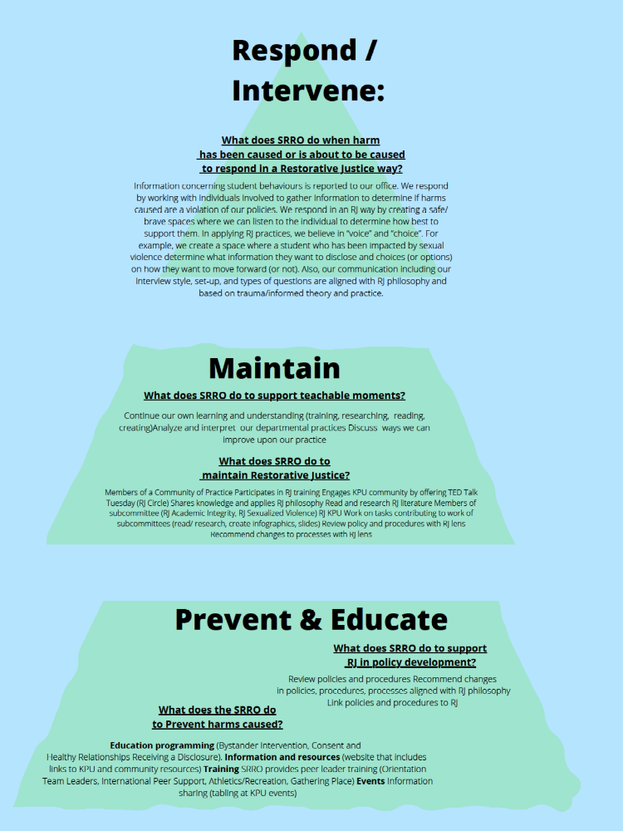
References
Harris, K. (2004). An expansive, transformative view of restorative justice. Contemporary Justice Review, 7(1), 117–141.
Lewellyn, J. (2018). Realizing the Full Potential of Restorative Justice. Accessed at:
https://policyoptions.irpp.org/magazines/may-2018/realizing-the-full-potential-of-restorative-justice/
Morrison, B. (2007). Restoring Safe School Communities: a whole school approach to bullying, violence, and alienation. Sydney, NSW: Federation Press.
Zehr, H. (2015). The Little Book of Restorative Justice. New York, NY: Good Books.

